***Exploring Blockchain Datasources***

***Objectives:***

1. ***Conduct online research to identify various blockchain networks***
2. ***Look into official documentation and forums to understand the data available***
3. ***Explore different data formats and structures used by various blockchain networks***

***Blockchain structure:***

*Just like what the name refers to ‘Block chain’ the structure of a Blockchain is an immutable chain of blocks containing data. Once a block is added it cannot be changed unless all succeeding blocks are changed aswell, that’s why a blockchain system commonly has multiple validators that conduct POW (Process of Work).*

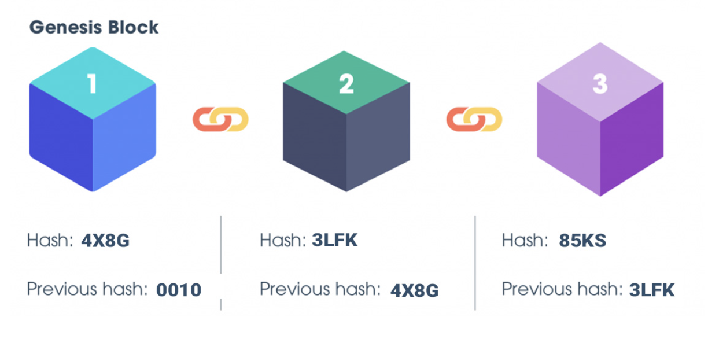

***Types of Blockchain Networks:***

*---Public Blockchain*

*---Private Blockchain*

*---Consortium Blockchains and Hybrid Blockchains*

***Overview:***

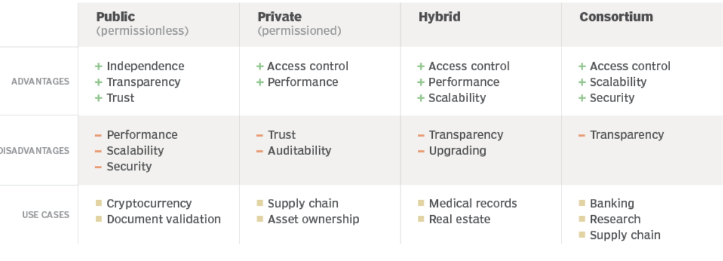

***Public Blockchain:***

*---Have no restrictions on the participants and the validator. (Means anyone can use this network)*

*---Since no one has full control, it allows this network to be De-Centralized*

*----Data has immutability as it is unchangeable*

*---All nodes connected to the blockchain have equal authority. Therefore, this blockchain becomes fully distributed*

*Comments: A common and most known Public Blockchain example is Cryptocurrencies. This type of blockchain is ideal for organizations that are built on transparency and trust, such as social support groups or non-governmental organizations.*

***Private Blockchain:***

*---Participant must be invited before they can be part of the blockchain*

*---Transactions are only visible to those who are part of the blockchain ecosystem*

*---Centralized and can be Regulated/Governed by someone*

*---There is a Network Administrator which takes care of a user’s permissions to control the accessibility to sensitive data*

*Comments: This network can be used for supply chain management, asset ownership and internal voting. The speed of private blockchains (less nodes) makes them ideal for cases where the blockchain (data) needs to be cryptographically secure (no 3rd parties will see the information) but the controlling entity doesn't want the information to be accessed by the public.*

***Hybrid Blockchains:***

*---Nodes are divided into two parts: Public and Private nodes*

*--- Organizations set up a private, permission-based system alongside a public permissionless system. This allows them to control who can access specific data stored in the blockchain, and what data will be publicly available.*

*--- In most cases transactions and records in a hybrid blockchain are not made public but can be verified when needed, such as by allowing access through a smart contract.*

*---1 Private entity can own the blockchain, but they cannot alter transactions*

*--- When a user joins a hybrid blockchain, they have full access to the network. The user's identity is protected from other users, unless they engage in a transaction. Then, their identity is revealed to the other party.*

*Comment: Hybrid blockchain has several strong use cases, one example is including real estate. Companies can use a hybrid blockchain to run systems privately but show certain information, such as listings, to the public. Medical records can be stored in a hybrid blockchain. The record can't be viewed by random third parties, but users can access their information through a smart contract. Governments could also use it to store citizen data privately but share the information securely between institutions.*

***Consortium Blockchains:***

*---Similar to a Hybrid that the Nodes can be Public/Private*

*---The difference in comparison to Hybrid is that multiple organizational members collaborate on a decentralized network. So instead of 1 entity owning a blockchain a group of entities have ownership*

*--- consortium blockchain is a private blockchain with limited access to a particular group, this eliminates the risks that come with just one entity controlling the network on a private blockchain.*

*Comment: Consortium can be used in many cases for example Banking and payments are two uses for this type of blockchain. Different banks can band together and form a consortium, deciding which nodes will validate the transactions. Research organizations can create a similar model, as can organizations that want to track food. It's ideal for supply chains, particularly food and medicine applications.*